Week 7 API Call Tests  
  
  
Here’s what I have so far testing my api with my key:  
  
  
// RecipeFinder class

class RecipeFinder {

    constructor(apiKey) {

        this.apiKey = apiKey;

        this.baseUrl = "https://api.spoonacular.com/recipes/complexSearch";

    }

    async findRecipesByIngredients(ingredients) {

        const url = `${this.baseUrl}?apiKey=${this.apiKey}&includeIngredients=${ingredients.join(',')}`;

        try {

            const response = await fetch(url);

            if (!response.ok) throw new Error('API request failed');

            const data = await response.json();

            this.displayRecipes(data.results);

        } catch (error) {

            console.error(error);

        }

    }

    displayRecipes(recipes) {

        recipes.forEach(recipe => {

            console.log(`Title: ${recipe.title}`);

            console.log(`Image: ${recipe.image}`);

            console.log(`Used ingredients count: ${recipe.usedIngredientCount}`);

            console.log(`Missed ingredients count: ${recipe.missedIngredientCount}`);

            console.log('----');

        });

    }

}

// Instantiate the class with your API key

const recipeFinder = new RecipeFinder('07b172f893d44c94b46e5e7f1b18cac0');

// Call the method to find recipes by ingredients

recipeFinder.findRecipesByIngredients(['tomatoes', 'onions']);

I made a quick little html file to test the output to see what it would pop back with, forced it to find recipes with tomatoes and onions. Got the following:  
  
  
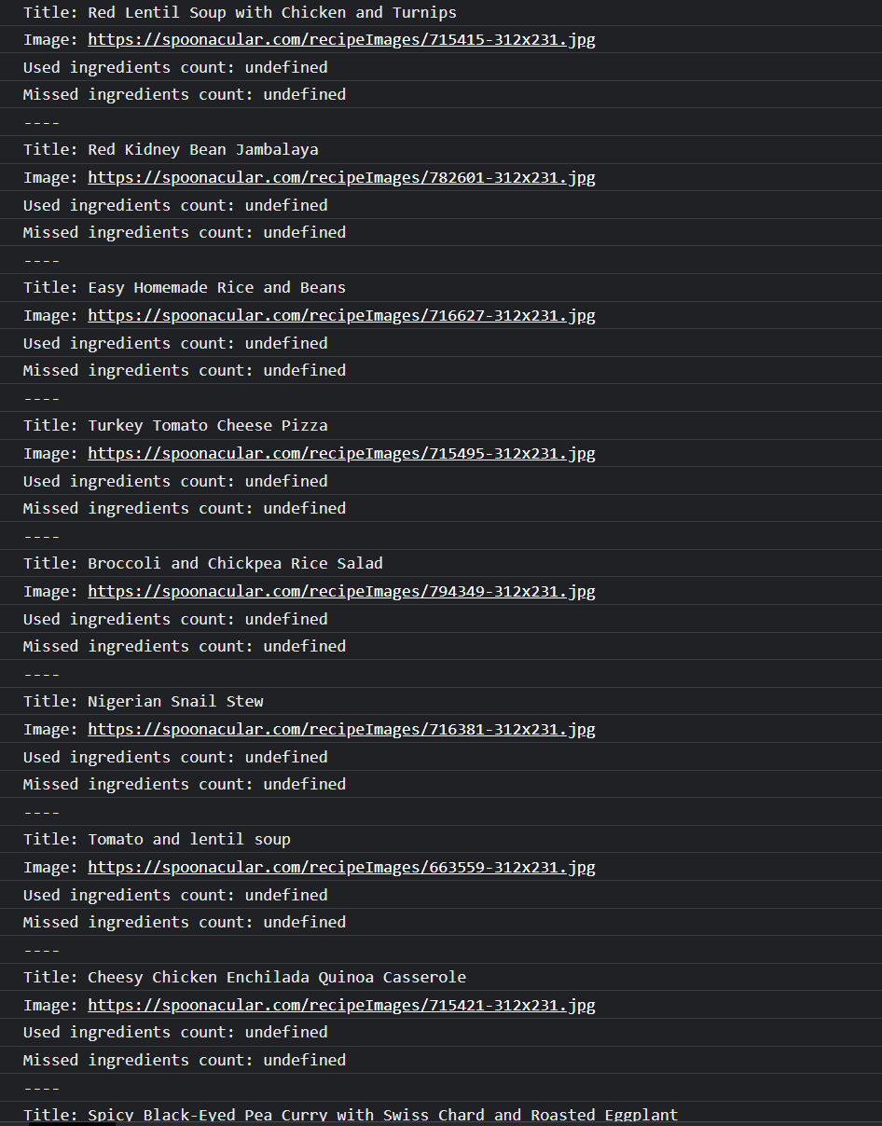

Having an issue, maybe with formatting the ingredients, but it’s not wanting to define the ingredients. Going to read their api documentation more to see what is going wrong. But at least it is functioning and calling for recipes.